**ASSISTED PRACTICE (THROUGHPUT CONTROLLER)**

Step1: Open Jmeter -> Add Thread Group

Step2: In Thread Group -> Give the Loop Count as “10”

Step3: Right click on Thread Group -> Add -> Logic controllers -> Throughput controller

Step4: In Throughput controller, Give the details as shown below:

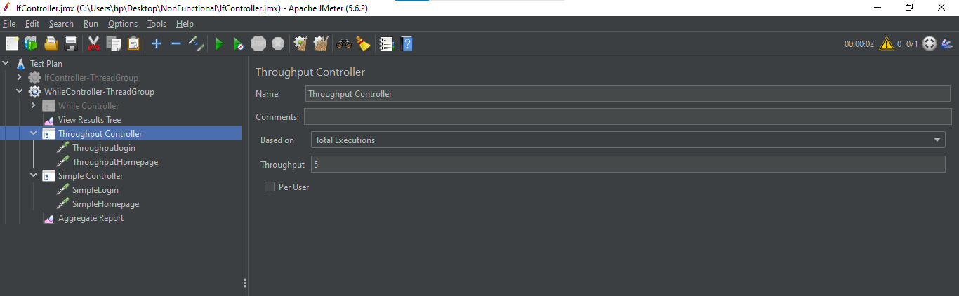

Step5: Right click on Throughput controller -> Add -> Sampler -> Add two HTTP Request

Step6: In 1st HTTP Request, Give the details as shown below:

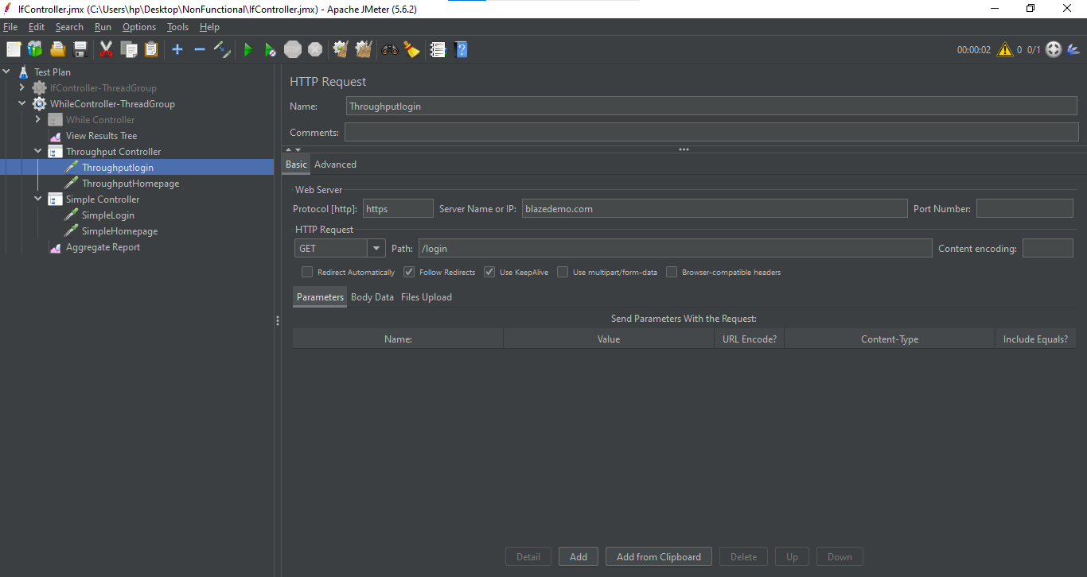

Step7: In 2nd HTTP Request, Give the details as shown below:

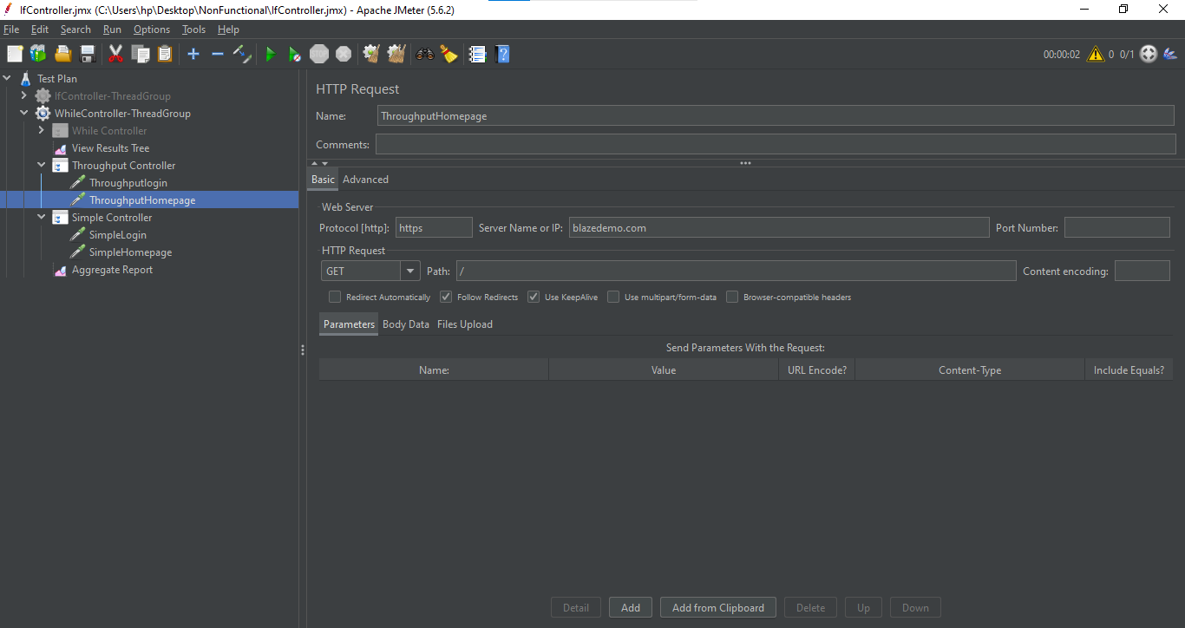

Step8: Right click on Thread Group -> Add -> Logic Controllers -> Simple Controller

Step9: Right click on Simple Controller -> Add -> Sampler -> Add two HTTP Request

Step10: In 1st HTTP Request, Give the details as shown below:

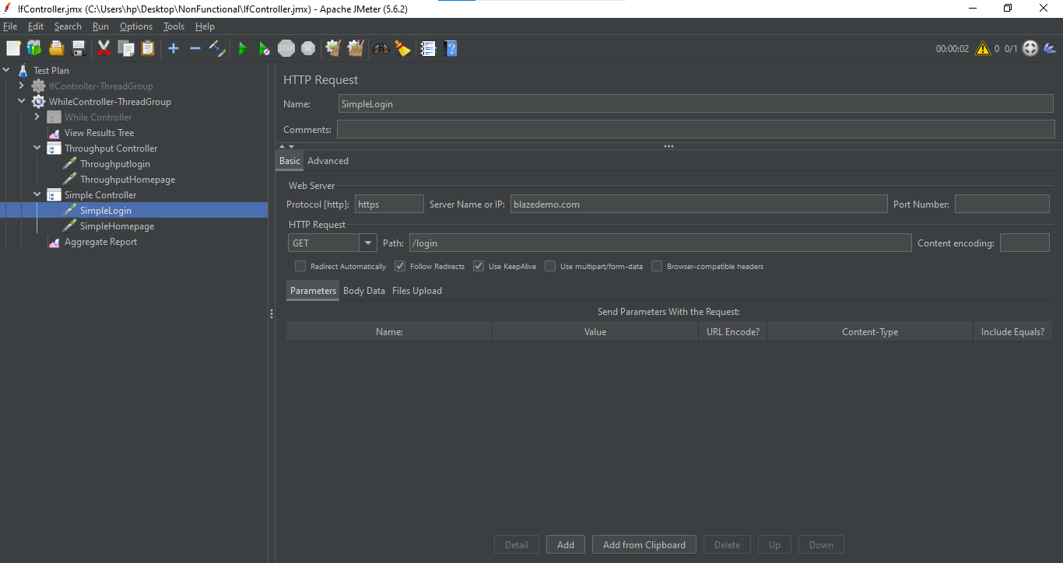

Step11: In 2nd HTTP Request, Give the details as shown below:

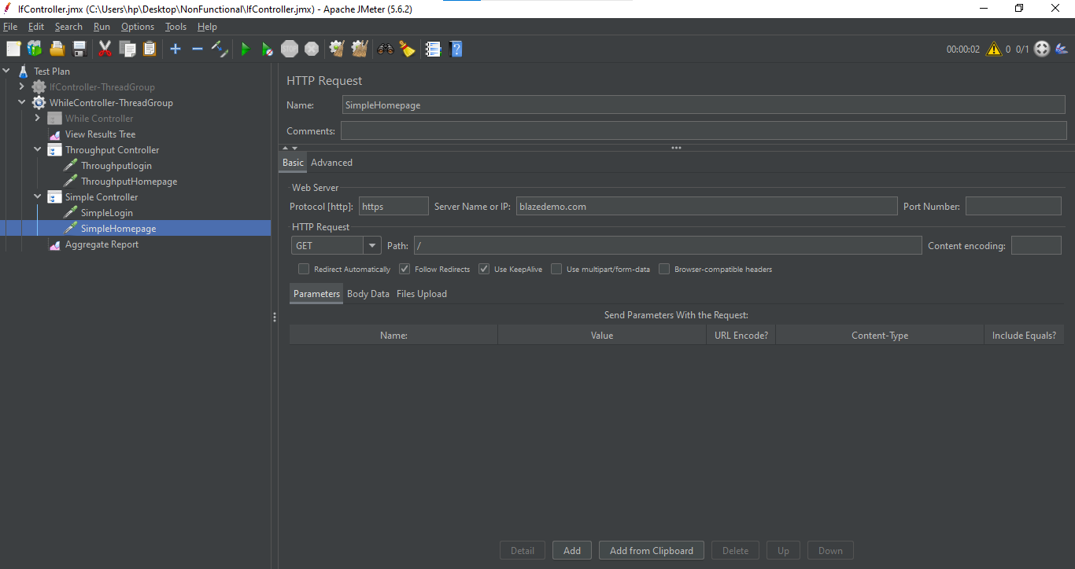

Step12: Right click on Thread Group -> Add -> Listener -> View Results Tree

Step13: Right click on Thread Group -> Add -> Listener -> Aggregate Report

View Results Tree:

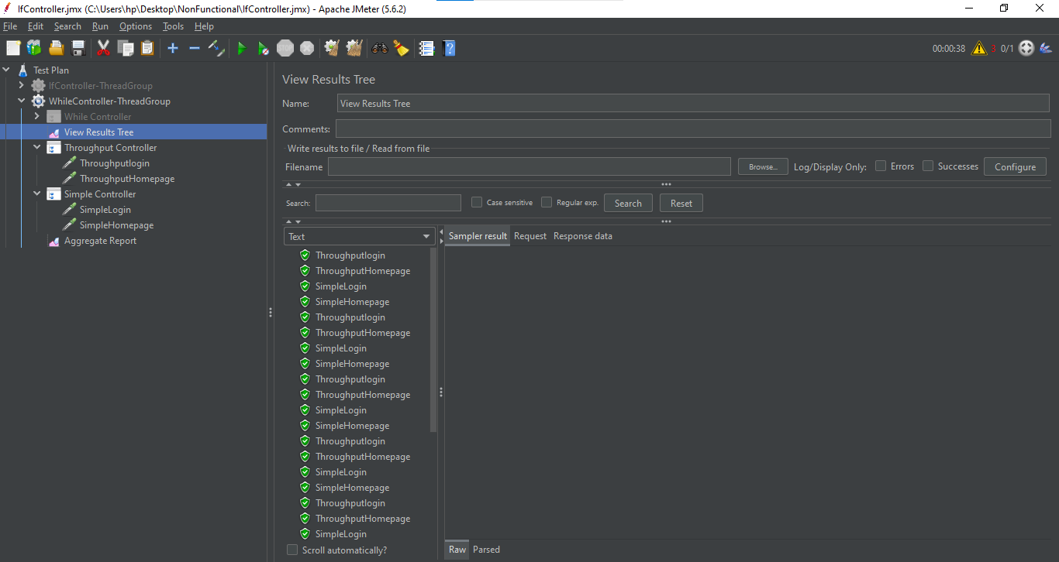

Aggregate Report:

